

My Target: ____ / 92 or ______ %

🖒 🖓 (Circle when your work is handed back)

**Name: __ _______ Teacher: __ _______**

**Due date: _____________________** *(Please note, it is* ***your responsibility*** *to hand in your assignment before the due date if you will be away on the day)*

Year 9 Humanities & Social Sciences:  *The Making of the Modern World*

Assessment 4: In-Class Historical Inquiry Task (5%)

***Task summary:***

**Part 1:**You will choose a soldier to conduct a historical research inquiry.You must create focus questions and take notes using your research journal (this booklet). Your research will focus on important events in the soldier’s life, as well as, their contribution to World War One.

**Part 2:** When you have collected and compiled all of your research information you will write a newspaper article on your chosen soldier. The article should be between 200 and 300 words.

**Use this website,** [**https://www.awm.gov.au/advanced-search/people**](https://www.awm.gov.au/advanced-search/people) **to search for a family member or a soldier you know of who served in World War One.**

Alternatively, you can choose a soldier from the following list to research:

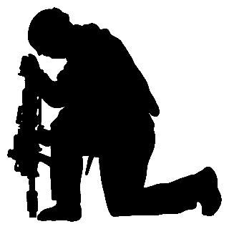

* William Throsby Bridges
* John Monash
* Sister Ella Tucker
* Private Richard Martin
* Captain Albert Jacka

***You will find these websites/links useful:***

1. National ANZAC Centre

http://www.nationalanzaccentre.com.au/story/

1. National Archives of Australia

<http://discoveringanzacs.naa.gov.au/learn/>

<https://discoveringanzacs.naa.gov.au/browse/places>

1. Australian War Memorial

<https://www.awm.gov.au/>

**Part A: Research Journal**

**Section 1: Planning the inquiry**

1. What is the name of the soldier you will research?

1. What exactly am I being asked to do? Highlight the key words from the task summary and list the tasks you need to complete. **(2 marks)**
2. Use the space below to brainstorm what you already know about World War One and/or your soldier. **(4 marks)**

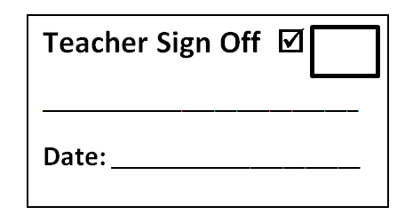

1. What questions do I need to ask? These will drive your inquiry so they must directly relate to the research focus (important events in the soldier’s life and their contribution to World War One). **(8 marks)**





























**NOTE-TAKING (40 marks)**

|  |  |
| --- | --- |
| Focus question 1: | Focus question 2: |
| Notes- | Notes- |



|  |  |
| --- | --- |
| Focus question 3: | Focus question 4: |
| Notes- | Notes- |



|  |  |
| --- | --- |
| Focus question 5: | Focus question 6: |
| Notes- | Notes- |



|  |  |
| --- | --- |
| Focus question 7: | Focus question 8: |
| Notes- | Notes- |



**Part B: Writing the newspaper article**

You must write a newspaper article with a **minimum of 200 words** and a **maximum of 300 words**. Make sure you include an image and quotes!

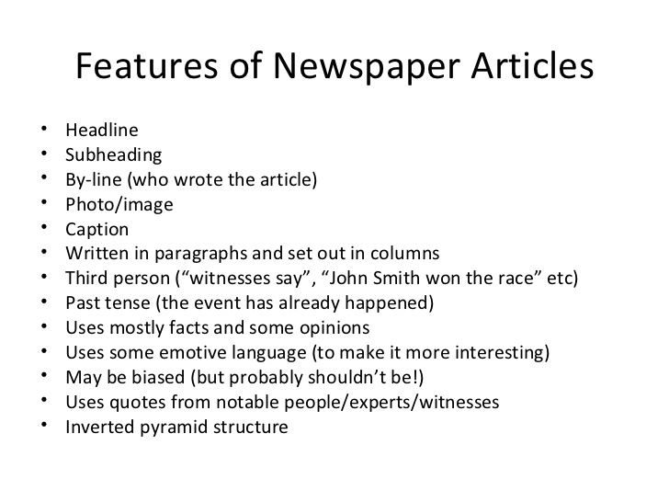

**Rules for writing a newspaper article:**

1. **Compile all your facts.** Before you write a news article, make a list or outline of all the pertinent facts and information that need to be included in the article. This fact list will help prevent you from leaving out any relevant information about the topic or story and will also help you write a clean, succinct article. **You will get this information from your notes.**
2. **Start with your lead.** News articles begin with a leading sentence that is meant to grab a reader's attention and interest them. This is one of the most important parts of the piece, so start with the leading statement when writing a news article. Your lead should be one sentence and should simply, but completely, state the topic of the article
3. **Give all the important details.** The next important step to writing News articles are including all the relevant facts and details that relate to your lead statement. Include the basics of what happened, where and when it took place, who is involved and why it's newsworthy. These details are important, because they are the focal point of the article that fully informs the reader.
4. **Follow up main facts with additional information.** After you've listed all the primary facts in your news article, include any additional information that might help the reader learn more, such as contact information, additional facts about the topic or people involved, or quotes from interviews. This additional information helps round out the article.
5. **Check facts before concluding.** Be sure to double check all the facts in your news article before you submit it, including names, dates, and contact information or addresses.
6. **Remain unbiased.** A news article is meant to convey direct facts, not the opinions of its writer. Keep your writing unbiased and objective. Avoid any language that is overly positive or negative or statements that could be construed as support or criticism.
7. **Conclude your article.** Make sure your news article is complete and finished by giving it a good concluding sentence. This is often a restatement of the leading statement or a statement indicating potential future developments relating to the article topic.

***Example newspaper articles***

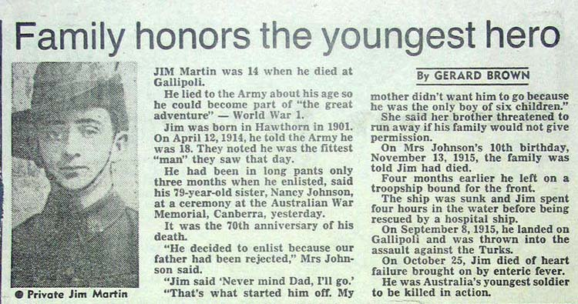

G. Brown. 1985. Family honors the youngest hero. Accessed 22/8/2018. <http://vrroom.naa.gov.au/records/?ID=19010>

http://resources.smh.com.au/smh/2007-11/images/logo_for_printer.png

**Anzac spirit celebrated by indigenous WW1 soldier’s family on visit to Albany**

November 2, 2014, Aleisha Orr

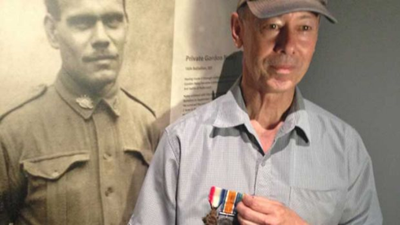

*Gordon Charles Naley and Michael Laing*

"Both non Aboriginal and Aboriginal people went to serve in the wars together and they were mates, they were all on the same level and had the same respect for each other and same friendship and I think that's the real Anzac spirit isn't it?"

These are the words of Michael Laing, the grandson of Gordon Charles Naley, an indigenous soldier who fought as part of the 16th Battalion in World War One.

It was only fitting that Mr Laing spoke about the Anzac spirit while in the West Australian city of Albany on the weekend, where tens of thousands of visitors converged to commemorate the departure of the first Anzac convoy 100 years on.

Mr Naley was part of the second Anzac convoy, he boarded the HMAT Ceramic on December 22, 1914 in Melbourne, which made its way to Albany, which ended up being the last sight of Australian land for those on board for some time.

"I can only guess when the war started up he'd formed some close friendships and caught up with the spirit of it all, probably that's how it happened.

"That Anzac spirit is an amazing spirit we have here in Australia, I hope it never dies, I think we all get something out of it and I hope for future generations they continue to carry it long after we are gone too."

|  |  |  |  |  |  |
| --- | --- | --- | --- | --- | --- |
| **Author** | **Date last updated** | **Title of Webpage** | **Date accessed** | **HTTP** | |
|  |  |  |  |  | |
|  |  |  |  |  | |
|  |  |  |  |  | |
|  |  |  |  |  | |
|  |  |  |  |  | |
|  |  |  |  |  | |
| **Author** | **Date of Publication** | **Title of Book** | **Publisher** | | **Place of Publication** |
|  |  |  |  | |  |
|  |  |  |  | |  |
|  |  |  |  | |  |

**Reference recording sheet**

*Please note that in order to obtain full marks you must submit a formal bibliography, the table below is only for recording your references as you are researching.*

|  |  |  |  |  |  |
| --- | --- | --- | --- | --- | --- |
| **Author** | **Date last updated** | **Title of Webpage** | **Date accessed** | **HTTP** | |
|  |  |  |  |  | |
|  |  |  |  |  | |
|  |  |  |  |  | |
|  |  |  |  |  | |
|  |  |  |  |  | |
|  |  |  |  |  | |
| **Author** | **Date of Publication** | **Title of Book** | **Publisher** | | **Place of Publication** |
|  |  |  |  | |  |
|  |  |  |  | |  |
|  |  |  |  | |  |

**Bibliography** **(8 marks)**

Using the reference recording sheet, list the sources according to the authors by placing them in alphabetical order, A – Z. If there is more than two authors, list the name of the first author and add the Latin term ‘et al’ which means ‘all the rest, or plural’.

Each reference of a source should follow the following format:

***Author*** *(surname and then initial of first name); then the source’s* ***title*** *(in italics or underlined); then the* ***publisher or full web address****; then the* ***date or year*** *created/produced, and in the case of a website, the* ***date accessed****.*



**Student Reflection (8 marks)**

Please respond to the following four questions (*be specific)*:

I learned …

|  |
| --- |
|  |
|  |
|  |
|  |
|  |

I was surprised …

|  |
| --- |
|  |
|  |
|  |
|  |
|  |

I discovered …

|  |
| --- |
|  |
|  |
|  |
|  |
|  |

I wonder …

|  |
| --- |
|  |
|  |
|  |
|  |
|  |





Name: ____________________________ My Target:_______/92 or _______%

Year 9 Assessment 4: In-Class Historical Inquiry Task (5%)

**MARKING GUIDE/RUBRIC**

|  |  |  |  |  |  |
| --- | --- | --- | --- | --- | --- |
| **PART A: Research journal** | | | | | **Total marks** |
|  |  |  | **1** | **2** |  |
| **Task summary** |  |  | Presents a task summary which lacks detail.  Task summary not completed (0). | Presents a detailed and comprehensive task summary. | **/2** |
|  |  |  | **0-2** | **3-4** |  |
| **Brainstorm** |  |  | Presents a brainstorm which lacks detail and shows limited prior knowledge on the chosen soldier/topic. | Presents a very detailed and comprehensive brainstorm which clearly outlines prior knowledge on the chosen soldier/topic. | **/4** |
|  | **0-2** | **3-4** | **5-6** | **7-8** |  |
| **Focus Questions** | Lists some simple questions which identify limited information.  No research questions are submitted. (0) | Devises a set of questions which identifies some information needed to address the research focus. | Devises a set of questions which mostly identifies the key information needed to address the research focus. | Devises a set of questions which clearly identifies the key information needed to address the research focus. | **/8** |
|  | **0-10** | **11-20** | **21-30** | **31-40** |  |
| **Note taking** | Provides limited and/ or no notes. Does not complete this section.  No notes are submitted. (0) | Provides generalised notes on the chosen soldier. Addresses research areas in some detail. Has constructed full sentences from key points though not always correctly. | Provides less detailed and mostly accurate notes on the chosen soldier. Addresses research areas mostly in detail and has constructed full sentences from key points somewhat effectively. | Provides very detailed comprehensive and accurate notes on the chosen soldier. Notes address research areas in detail and has changed key points into full sentences effectively.  Uses evidence from a range of sources. | **/40** |

|  |  |  |  |  |  |
| --- | --- | --- | --- | --- | --- |
| **PART B: Newspaper Article** | | | | | **Total marks** |
|  |  |  |  | 1 |  |
| **Appropriate Headline Included** |  |  |  | An appropriate headline is included. | **/1** |
|  |  |  |  | **1** |  |
| **Student name is included** |  |  |  | Student’s name is included. | **/1** |
|  |  |  |  | **1** |  |
| **Date is included** |  |  |  | Date is included. | **/1** |
|  |  |  | **1** | **2** |  |
| **Image** |  |  | An image is included no caption or reference.  No image (0) | An image is included with an appropriate caption, pictures source is referenced in the bibliography. | **/2** |
|  |  | **1** | **2** | **3** |  |
| **Introductory Paragraph** |  | No clear introduction is included. | An introduction is included, provides good detail about what the main topic of the article. | A well-constructed introduction is included, provides good detail about what the main topic of the article. | **/3** |
|  | **0-2** | **3-4** | **5-6** | **7-8** |  |
| **Body information** | Limited areas of the research focus are addressed. | Some areas of the research focus are addressed. | Most areas of the research focus are addressed in some detail. | All areas of the research focus are addressed in detail. | **/8** |
|  |  | **1** | **2** | **3** |  |
| **Conclusion** |  | A simple concluding sentence is included. | A conclusion is included that summarises the main topic of the article. | A well-constructed conclusion that summarises the main topic of the article. | **/3** |
|  |  | **1** | **2** | **3** |  |
| **Spelling, punctuation and editing.** |  | Frequently misspells common words, consistently makes punctuation errors and identifies very few or no errors in own writing. | Spells most words correctly, misspells some new technical words and edits own work to improve content, structure and vocabulary. | Spells difficult words accurately, uses varied punctuation for clarity and precision of meaning and consistently uses editing strategies to demonstrate control over content. | **/3** |

|  |  |  |  |  |  |  |  |  |  |  |  |
| --- | --- | --- | --- | --- | --- | --- | --- | --- | --- | --- | --- |
| **Bibliography** | | | | | | | | | | | **Total marks** |
|  | | | **0-3** | | | **4-6** | | | **7-8** | |  |
|  | | | Bibliography includes a limited list of sources which may follow the referencing technique approved by the school, however, does not incorporate all requirements.  No bibliography submitted (0) | | | Bibliography includes a smaller range of sources which mostly follows the referencing technique approved by the school. | | | Collects information from a comprehensive number of sources and records a variety of key information which relates to the chosen geomorphic hazard, incorporating ethical protocols, which correctly follow the referencing technique approved by the school. | | **/8** |
|  | | | | | | | | | | | |
| **Self-reflection** | | | | | | | | | | | |
|  | **0-2** | | | **3-4** | | | **5-6** | | **7-8** | |  |
|  | Does not complete all sections of the self-reflection.  (Each section worth 2 marks)  No self –reflection submitted(0) | | | Completes all four sections of the self-reflection but with less detail.  (Each section worth 2 marks) | | | Completes parts of the self-reflection using full sentences and uses some detailed examples.  (Each section worth 2 marks) | | Completes all four sections of the self-reflection using full sentences and uses detailed examples.  (Each section worth 2 marks) | | **/8** |
|  | | | | | | | | | | | |
| **Assessment 4: Overall marks allocation** | | | | | | | | | | | |
| Part A: research journal | | Part B: Newspaper article | | | Bibliography | | | Reflection | | **TOTAL** | |
| **/54** | | **/22** | | | **/8** | | | **/8** | | **/92** | |

Overall comment: